Supplementary figure
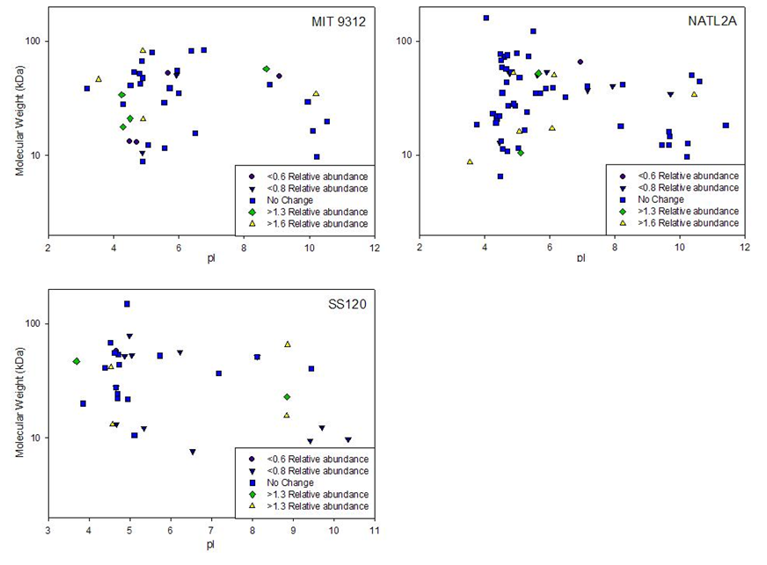
Figure S1. Virtual 2D gel representations of proteins identified from MIT9312 (top left), NATL2A (top right), and SS120 (bottom left).

